**Practical -1**

**Aim: Create an excel file convert it to .csv format and prepare ARFF files of it.**

**STEP -1 :-** We will create a new Excel Spreadsheet and write the sample data in it .

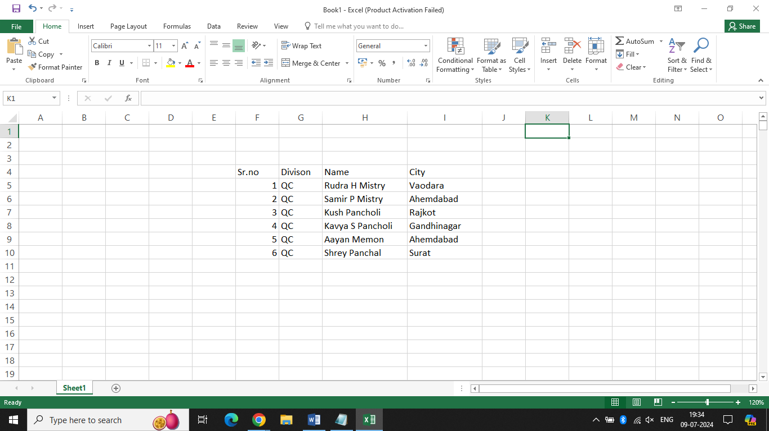

**Step -2 :-** Open notepad and write the below code and save the file with extension of .csv extension .

Here, CSV stands for Comma Separated Values .

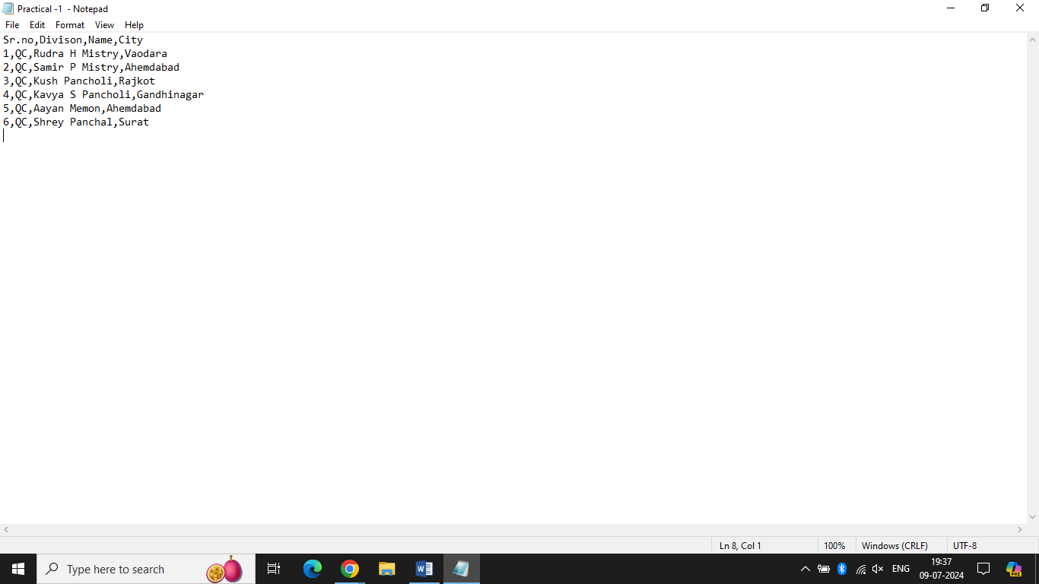

**Step -3 :-** Now create arff file. ARFF stands for Attribute Relation File Format. Write this below file in notepad & save as ‘Students.arff’.

Code :-

@relation employee_data

@attribute Sr_no numeric

@attribute Division {QC}

@attribute Name string

@attribute City {Vaodara, Ahemdabad, Rajkot, Gandhinagar, Surat}

@data

1,QC,'Rudra H Mistry',Vaodara

2,QC,'Samir P Mistry',Ahemdabad

3,QC,'Kush Pancholi',Rajkot

4,QC,'Kavya S Pancholi',Gandhinagar

5,QC,'Aayan Memon',Ahemdabad

6,QC,'Shrey Panchal',Surat

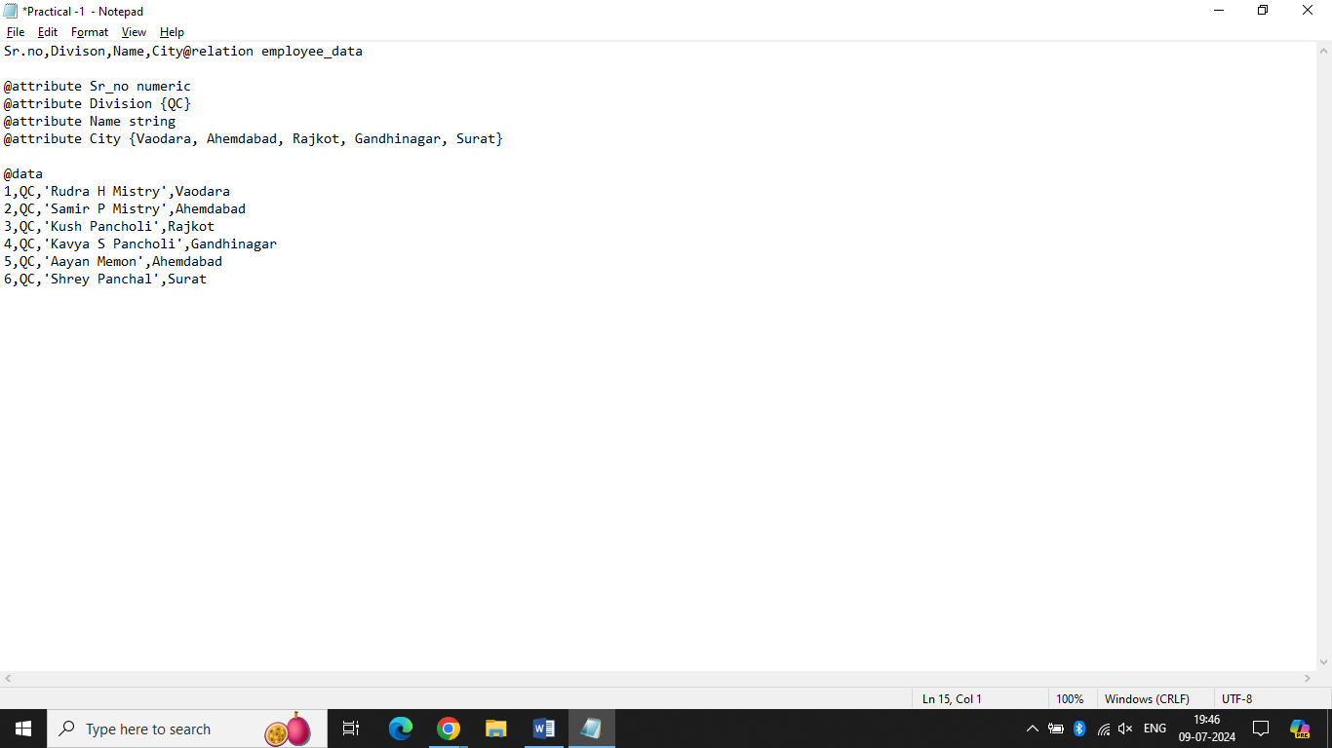

**Practical -2**

**Aim: Write the use of ARFF files taking input and display the output of the files.**

An ARFF (Attribute-Relation File Format) file is a plain text file format designed to describe datasets, specifically for use with the Weka machine learning software. ARFF files facilitate various data preprocessing and data cleaning operations, making them an essential tool in machine learning workflows.

**Structure of an ARFF File**

ARFF files are structured into two main sections:

1. **Header Section**
2. **Data Section**

**1.Header Section:-**

The header section provides metadata about the dataset, including the name of the dataset (relation) and the attributes (columns) along with their data types. This section uses specific keywords, all beginning with the @ symbol.

**Key Elements:**

* @relation: Specifies the name of the dataset.
* @attribute: Defines each attribute (column) and its data type.

**Supported Data Types:**

* **nominal**: Enumerated values enclosed in curly brackets (e.g., {A, B, C}).
* **string**: Accepts textual data.
* **numeric**: Stores numerical values.
* **date**: Stores dates.

Example Header:

@relation student

@attribute sl_no numeric

@attribute name string

@attribute div {A, B, C, D}

@attribute city string

**2.Data Section :-**

The data section follows the header and contains the actual dataset entries. It begins with the @data keyword and includes one record per line, following the order of attributes defined in the header.

**Key Elements:**

* @data: Indicates the start of the data section.
* %: Comments are prefixed with the % symbol.

**How to Create and open arff file:-**

We need a Data Mining tool for using Data mining functionalities. So, We have used Weka as the development tool for Data Mining.

**Step 1**: Open any text editor and paste the above code.

**Step 2:** Save the file with student.arff file extension

**Step 3**: Open weka tool

**Step 4**: Click on Explorer

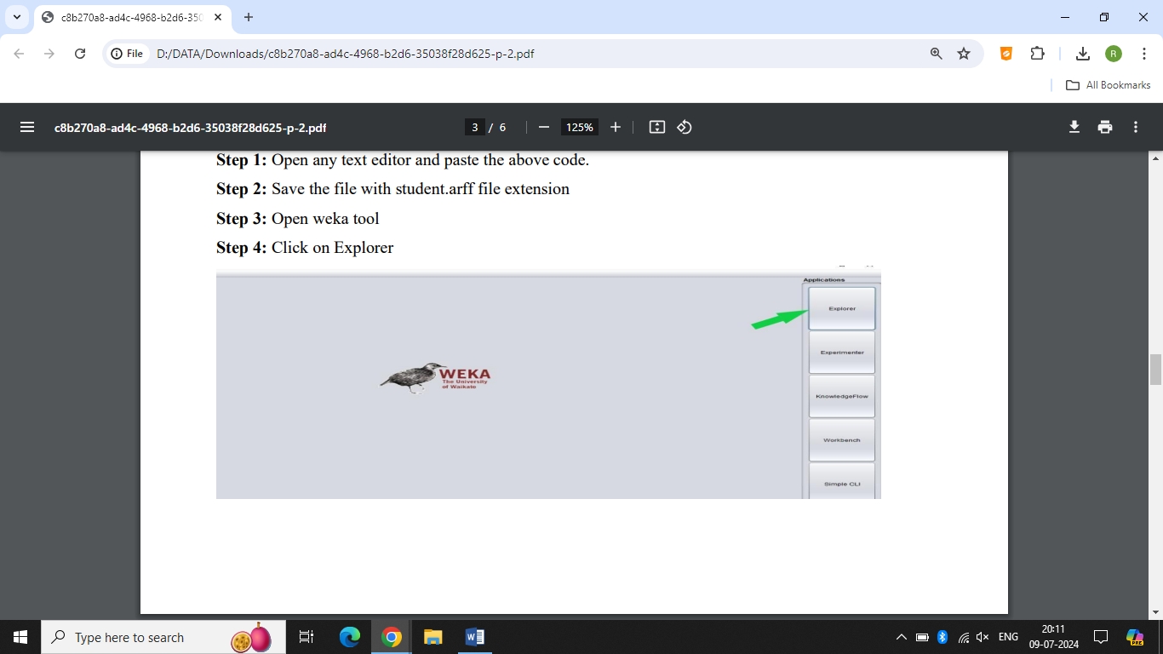

**Step – 5:-** Click on Open File .

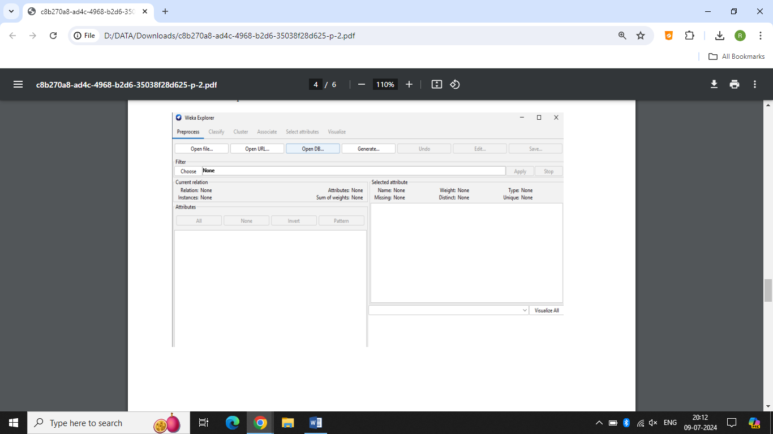

**Step – 6 :-** Select/Locate arff file from disk then click On Open.

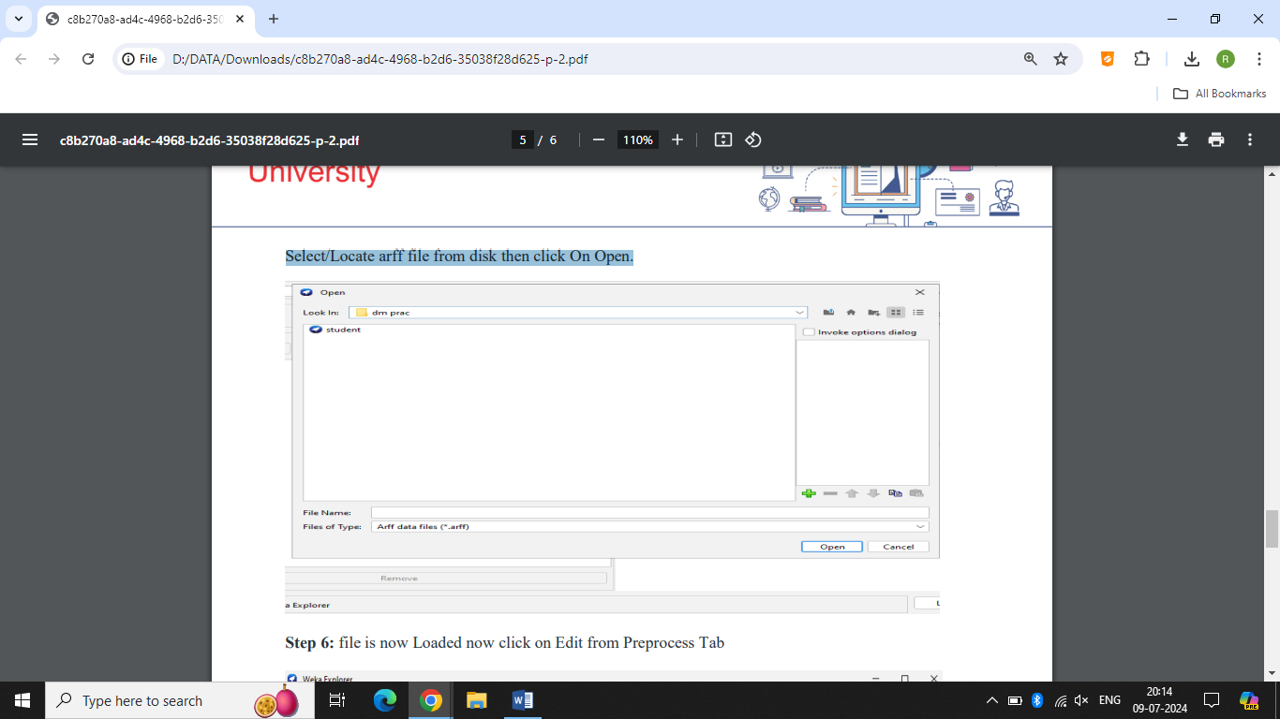

**Step 7:-**File is now Loaded now click on Edit from Preprocess Tab

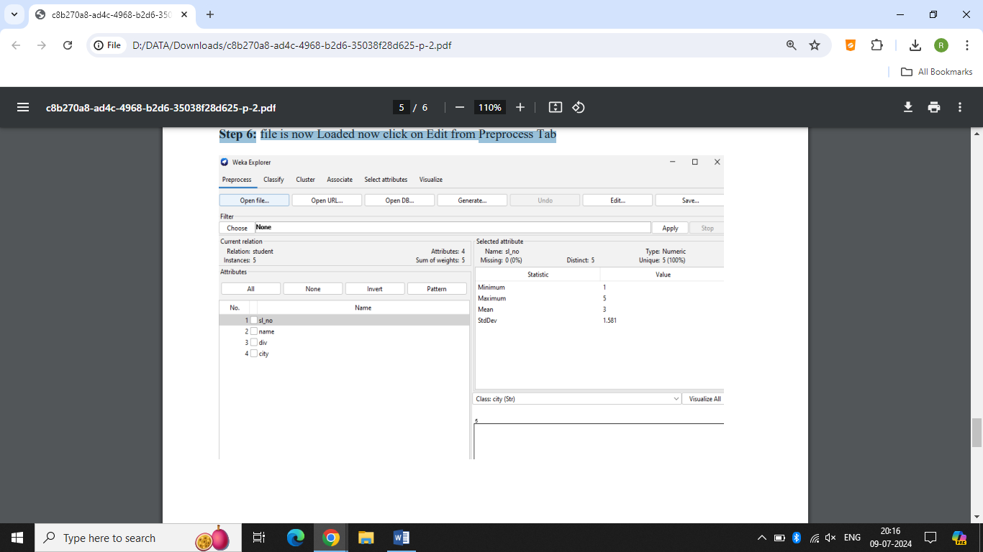

**Step 7:-** The output of the dataset will be shown like this .

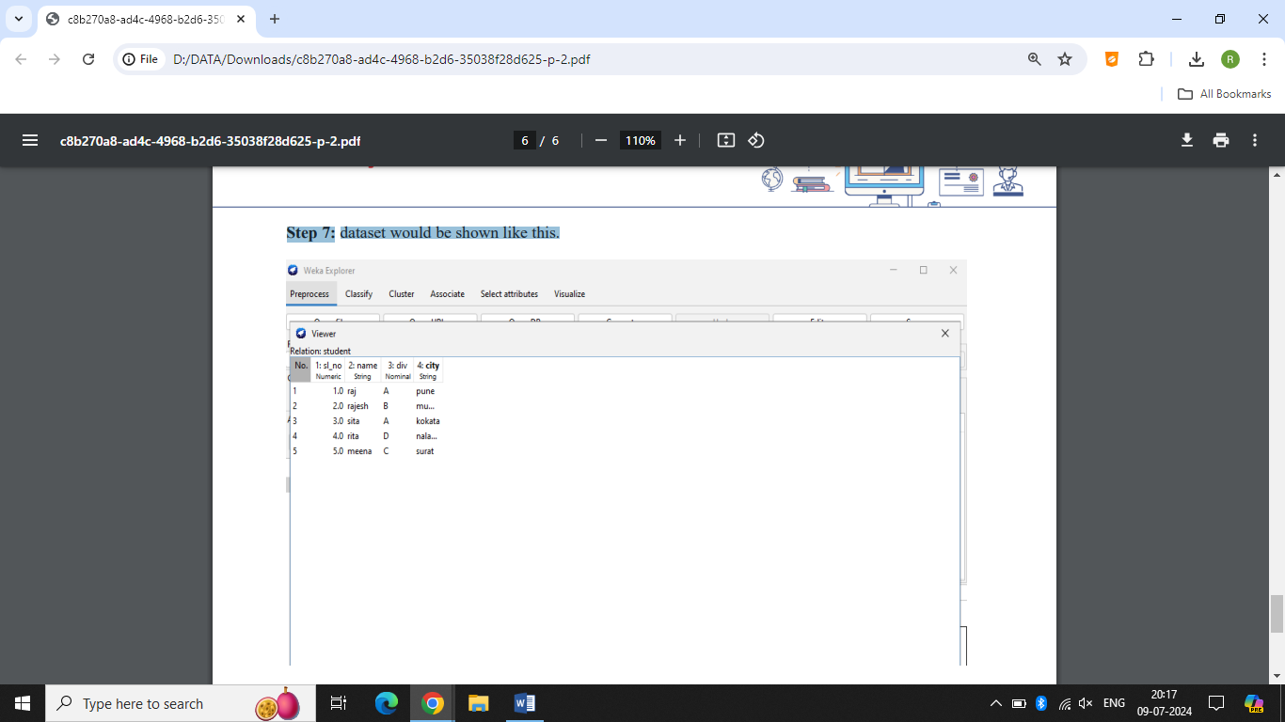

**Practical – 3**

**Aim :-** Study various Data Mining tool and their applications.

**Certainly! Here is an expanded version with additional details:**

**---**

**1. ORANGE:**

**⮚** Orange is a component-based visual programming software designed for data mining, machine learning, and data analysis. It provides a user-friendly environment that allows both beginners and advanced users to perform complex data analysis tasks without extensive programming knowledge.

⮚ Components in Orange are called widgets. These widgets range from simple data visualization and subset selection to preprocessing, empirical evaluation of learning algorithms, and predictive modeling. Widgets can be easily connected to create complex data analysis workflows.

⮚ Visual programming in Orange is facilitated through an intuitive drag-and-drop interface. Users can create workflows by linking predefined or custom-designed widgets. This interface simplifies the process of data manipulation, making it accessible to users with varying levels of expertise. Advanced users can also leverage Orange as a Python library to manipulate data and modify widgets according to their needs.

⮚ Orange consists of a canvas interface onto which users place widgets and create data analysis workflows. Widgets provide fundamental functionalities such as reading data, displaying data tables, feature engineering, training predictive models, comparing different learning algorithms, and visualizing data elements. The interactive nature of Orange allows users to explore visualizations dynamically and feed selected subsets of data into other widgets for further analysis.

⮚ Key features of Orange include:

- Data Import and Export: Orange supports various data formats including CSV, Excel, SQL databases, and more. This flexibility makes it easy to integrate data from multiple sources.

- Data Visualization:Users can create a wide range of visualizations such as scatter plots, histograms, box plots, heatmaps, and more to gain insights into their data.

- Data Preprocessing: Widgets for data preprocessing include filtering, normalization, imputation, and feature selection, enabling users to prepare their data for analysis effectively.

- Machine Learning: Orange provides a variety of machine learning algorithms for classification, regression, clustering, and association rule learning. Users can easily train and evaluate models using these algorithms.

- Evaluation and Comparison: Widgets for model evaluation and comparison allow users to assess the performance of different algorithms and select the best model for their data.

- Scripting and Automation: For advanced users, Orange can be extended through scripting in Python, allowing for automation of repetitive tasks and customization of widgets.

- Educational Use: Orange is widely used in education for teaching data science and machine learning concepts due to its intuitive interface and powerful features.

⮚ Orange is an open-source tool, which means it is freely available for use and modification. The active community of users and developers contributes to its continuous improvement and expansion of functionalities. This makes Orange a versatile and powerful tool for anyone involved in data analysis, from students and educators to researchers and data scientists.

Overall, Orange is a robust platform that bridges the gap between visual programming and powerful data analysis capabilities, making it a valuable asset in the toolkit of any data enthusiast.

**2. WEKA:**

⮚ WEKA, short for Waikato Environment for Knowledge Analysis, is an open-source software suite that provides a comprehensive collection of tools for data preprocessing, implementation of various machine learning algorithms, and data visualization. These tools enable users to develop machine learning techniques and apply them to real-world data mining problems effectively.

⮚ Weka is a robust collection of machine learning algorithms designed specifically for data mining tasks. It includes tools for:

* **Data Preparation:** Handling and transforming raw data to a suitable format for analysis.
* **Classification:** Algorithms to categorize data into predefined classes.
* **Regression:** Techniques to predict continuous values.
* **Clustering:** Grouping data into clusters based on similarity.
* **Association Rule Mining:** Discovering relationships between variables in large datasets.
* **Visualization:** Tools to visualize data and model results for better understanding and interpretation.

⮚ Weka provides a rich set of visualization tools and algorithms for data analysis and predictive modeling. The software includes graphical user interfaces (GUIs) that make it easy to access these functions without extensive programming knowledge. These interfaces include:

* **Explorer:** A comprehensive environment for data exploration and machine learning.
* **Experimenter:** An environment for performing systematic experiments to compare different learning algorithms.
* **KnowledgeFlow:** A dataflow-oriented interface that allows users to design and execute data mining workflows visually.
* **Simple CLI:** A command-line interface for advanced users who prefer scripting their data analysis tasks.

⮚ Weka supports a variety of standard data mining tasks, with particular emphasis on:

* **Data Preprocessing:** Techniques for cleaning, transforming, and preparing data, including filtering, normalization, and attribute selection.
* **Clustering:** Methods like K-means and EM for grouping data based on inherent similarities.
* **Classification:** Algorithms such as decision trees, random forests, support vector machines, and neural networks for assigning labels to data points.
* **Regression:** Techniques for predicting continuous values, including linear regression and decision trees.
* **Visualization:** Tools for creating various plots and charts to explore data and model performance.
* **Feature Selection:** Methods to identify the most relevant features for building predictive models, improving model performance, and reducing overfitting.

⮚ Input to Weka is expected to be formatted according to the Attribute-Relation File Format (ARFF), with files typically bearing the .arff extension. This format consists of a header describing the attributes (features) and their types, followed by the data itself. All of Weka's techniques assume that data is available as a single flat file or relation, where each data point is described by a fixed number of attributes. These attributes are usually numeric or nominal, but Weka also supports some other attribute types.

⮚ Key features of Weka include:

* **Interoperability:** Weka can interface with other data mining tools and libraries, enhancing its functionality and flexibility.
* **Extensibility:** Users can extend Weka by adding new algorithms and tools, leveraging its modular architecture.
* **Automation:** Weka supports scripting and automation, allowing users to streamline their data analysis workflows.
* **Integration:** Weka can be integrated with other software and platforms, such as databases, for more seamless data processing and analysis.
* **Educational Use:** Weka is widely used in academic settings for teaching and research in machine learning and data mining, thanks to its comprehensive toolset and user-friendly interfaces.

⮚ Weka's extensive documentation and active community provide ample support for users at all levels. This makes Weka a versatile and powerful tool for anyone looking to apply machine learning and data mining techniques to real-world problems, from students and educators to researchers and industry professionals.

**3. XLMiner:**

⮚ XLMiner is a comprehensive data mining software tool specifically designed for business analytics. It facilitates the creation and testing of predictive models through familiar interfaces such as Excel, SQL, and PowerPivot. This makes advanced data analysis accessible to business professionals who may not have extensive programming or data science expertise.

⮚ With the XLMiner Analysis ToolPak App, users can perform a wide range of statistical analyses similar to those available in the desktop version of Microsoft Excel's Analysis ToolPak. The App extends these capabilities by providing all 19 interactive functions found in the Excel Analysis ToolPak, plus an additional 20th function—logistic regression—often requested by users. This extended functionality makes XLMiner a powerful tool for both basic and advanced statistical analysis.

⮚ Key features and functionalities of XLMiner include:

* **Statistical Analysis:** Perform various statistical tests and analyses, including descriptive statistics, hypothesis testing, analysis of variance (ANOVA), correlation, and more.
* **Predictive Modeling:** Create and evaluate predictive models using techniques such as linear regression, logistic regression, decision trees, and time series forecasting.
* **Data Visualization:** Generate charts and graphs to visualize data distributions, relationships, and model predictions.
* **Data Preparation:** Tools for data cleaning, transformation, and preprocessing to ensure data is in the optimal format for analysis.
* **Interactive Interface:** The App's Task Pane input fields and worksheet output are designed to be very familiar to Excel Analysis ToolPak users, providing a seamless transition and intuitive user experience.
* **Integration with Excel:** XLMiner integrates seamlessly with Excel, allowing users to leverage their existing knowledge of Excel functions and formulas while extending their analytical capabilities.
* **SQL and PowerPivot Support:** Users can directly access and analyze data from SQL databases and PowerPivot, enhancing the tool's versatility and enabling the analysis of large and complex datasets.
* **Logistic Regression:** In addition to the standard functions, XLMiner includes logistic regression, a key technique for modeling binary outcomes, such as predicting customer churn or conversion rates.

⮚ Benefits of using XLMiner:

* **Ease of Use:** Designed for business professionals, XLMiner offers an intuitive interface that simplifies complex data analysis tasks.
* **Enhanced Decision Making:** By providing powerful data mining and predictive modeling capabilities, XLMiner helps businesses make data-driven decisions and uncover valuable insights.
* **Cost-Effective:** Leveraging Excel as a platform, XLMiner provides a cost-effective solution for advanced analytics without the need for expensive software or extensive training.
* **Educational Use:** XLMiner is also used in academic settings for teaching data mining and business analytics, providing students with hands-on experience using industry-relevant tools.

⮚ Typical applications of XLMiner include:

* **Marketing Analytics:** Analyzing customer data to segment markets, predict customer behavior, and optimize marketing campaigns.
* **Financial Analysis:** Forecasting financial performance, assessing risk, and developing investment strategies.
* **Operations Management:** Optimizing supply chain operations, inventory management, and resource allocation.
* **Human Resources:** Predicting employee turnover, assessing job satisfaction, and optimizing workforce planning.

Overall, XLMiner serves as a versatile and powerful tool for business analytics, enabling users to perform a wide range of statistical analyses and predictive modeling tasks within the familiar environment of Excel. This makes it an invaluable asset for business professionals seeking to leverage data for strategic decision-making and operational improvements.

**4. RapidMiner:**

⮚ RapidMiner is a comprehensive data science platform designed for enterprises. It focuses on analyzing the collective impact of organizations' employees, expertise, and data, facilitating collaboration across the entire AI lifecycle. RapidMiner claims to be used by more than 1 million people worldwide, making it one of the most popular tools in the field of data science and machine learning.

⮚ Originally known as YALE (Yet Another Learning Environment), RapidMiner has evolved significantly to support a wide range of data analysis and machine learning tasks. Its robust platform is designed to cater to diverse analytics users, from data scientists and analysts to business users, promoting broad AI adoption within organizations.

⮚ RapidMiner operates on a client/server model. The server component can be deployed on-premises or in public or private cloud infrastructures, providing flexibility and scalability to meet various enterprise needs. This architecture allows for centralized management, collaboration, and security of analytical processes and data.

⮚ One of RapidMiner's key strengths is its ability to deliver 99% of an advanced analytical solution through template-based frameworks. These frameworks accelerate the delivery of analytical projects and minimize errors by nearly eliminating the need to write code. This approach makes advanced analytics accessible to users with limited programming skills while ensuring high-quality and consistent results.

⮚ RapidMiner offers a wide range of data mining and machine learning procedures, including:

* **Data Loading and Transformation (ETL):** Tools for extracting, transforming, and loading data from various sources, ensuring data is prepared for analysis.
* **Data Preprocessing and Visualization:** Techniques for cleaning, normalizing, and visualizing data, helping users understand and prepare their data for modeling.
* **Predictive Analytics and Statistical Modeling:** A broad selection of machine learning algorithms and statistical models for tasks such as classification, regression, clustering, and anomaly detection.
* **Evaluation:** Comprehensive evaluation metrics and validation techniques to assess model performance and ensure accuracy.
* **Deployment:** Capabilities for deploying models into production, integrating them with business processes and applications to drive actionable insights.

⮚ Written in the Java programming language, RapidMiner provides a graphical user interface (GUI) that allows users to design and execute analytical workflows visually. This drag-and-drop interface simplifies the creation of complex workflows, enabling users to focus on analysis rather than coding.

⮚ Key features and functionalities of RapidMiner include:

* **Automated Machine Learning (AutoML):** Tools that automate the process of selecting, tuning, and validating machine learning models, making it easier to achieve optimal performance.
* **Text Mining:** Capabilities for processing and analyzing text data, including natural language processing (NLP) techniques.
* **Time Series Analysis:** Specialized tools for analyzing and forecasting time-dependent data.
* **Deep Learning:** Support for building and training deep learning models using popular frameworks such as TensorFlow and Keras.
* **Integration:** Connectivity with various data sources, including databases, cloud storage, and big data platforms like Hadoop and Spark.
* **Collaboration:** Features that facilitate collaboration among team members, including version control, project sharing, and reproducibility of results.
* **Extensibility:** An open architecture that allows users to extend RapidMiner's functionality by integrating custom R and Python scripts, as well as additional plugins.

⮚ RapidMiner's platform also emphasizes:

* **Ease of Use:** Designed to be user-friendly, RapidMiner enables users to quickly create and iterate on data science projects without requiring deep technical knowledge.
* **Enterprise-Grade Security:** Robust security features to protect data and analytical processes, ensuring compliance with organizational policies and industry regulations.
* **Scalability:** Capable of handling large-scale data and complex analytical workloads, supporting the needs of growing enterprises.
* **Comprehensive Support and Community:** Access to extensive documentation, tutorials, and an active community of users and experts for support and knowledge sharing.

RapidMiner's extensive capabilities and user-centric design make it a powerful tool for enterprises looking to harness the power of data science and machine learning to drive business innovation and competitive advantage.

**Practical -5**

**Aim :- Compare various Data Mining Techniques available in Weka .**

|  |  |  |  |
| --- | --- | --- | --- |
| **CLASSIFICATION** | **CLUSTERING** | **REGRESSION** | **ASSOCIATION** |
| Classification a is supervise learning approach where a specific label is provided to the machine to classify new observations .Here the machine needs proper testing and training for the label verification | Clustering is an un supervised learning approach where grouping is done on similarities basis. | Regression is a supervised learning approach that is used to predict any continuous-valued attribute. Regression helps any business organization to analyze the target variable and predictor variable  relationships. | Association rule learning is a type of unsupervised learning technique that finds interesting associations and relationships among large sets of data items. |
| It uses a training dataset | It does not use a training  dataset | It uses a train and test  dataset | It uses a training dataset |
| It uses algorithm to categorize the new data as per the observation of the training set. | It uses statistical concepts in which the data set is divided into subset of the same features | It uses algorithm to find the new data as per the observation of the training set. | It uses algorithm to discover interesting patterns, associations, or  relationships within large datasets. |
| Output is categorical quantity | Assigns data points into clusters | Output is continuous quantity | The output of association techniques in data mining typically includes discovered patterns, associations, or relationships within the  dataset. |
| The main aim is to forecast or predict | The main aim is to group similar items clusters | The main aim to forecast and predict. | the main aim of association analysis is to extract meaningful insights from  data |
| Eg: classify mail as spam or non spam | Eg: find all transaction which are fraudulent in  nature | Eg: predict stock market price | Eg:the rule "If a customer buys bread, they are also  likely to buy milk" |
| Algorithm: logistic  Regression | Algorithm: k-means | Algorithm: Linear  Regression | Algorithm :Apriori  Algorithm |

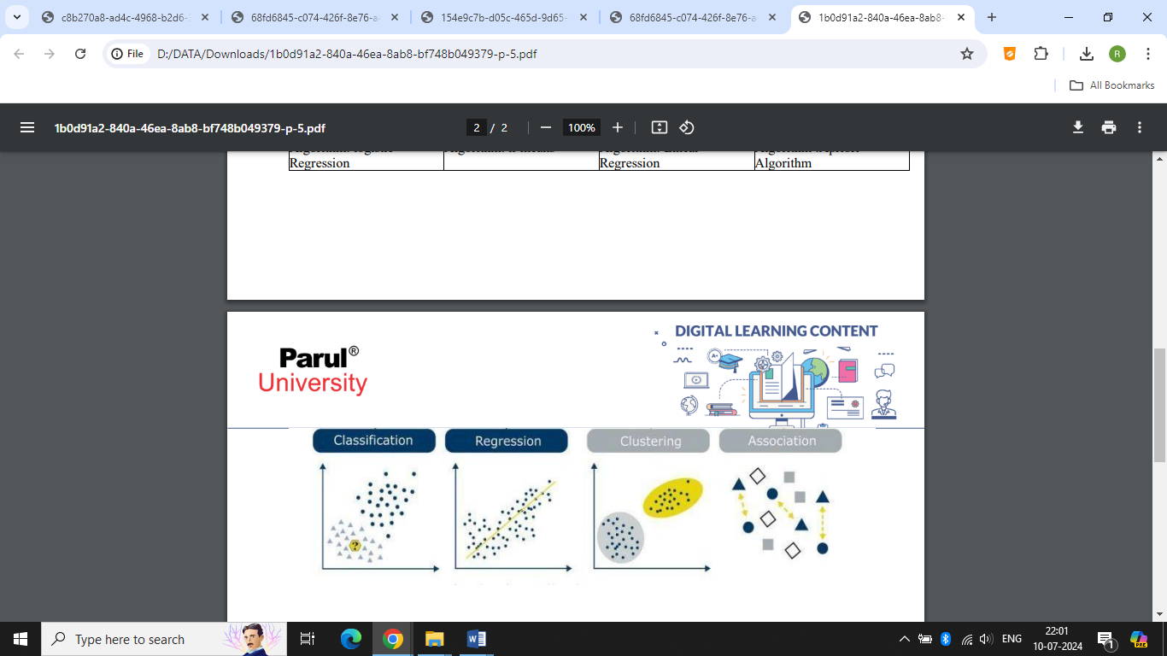

**Practical -4**

**Aim :- Install and Configure WEKA Tool.**

**Step 1:** Visit this official website of WEKA using any web browser. Click on Free Download.

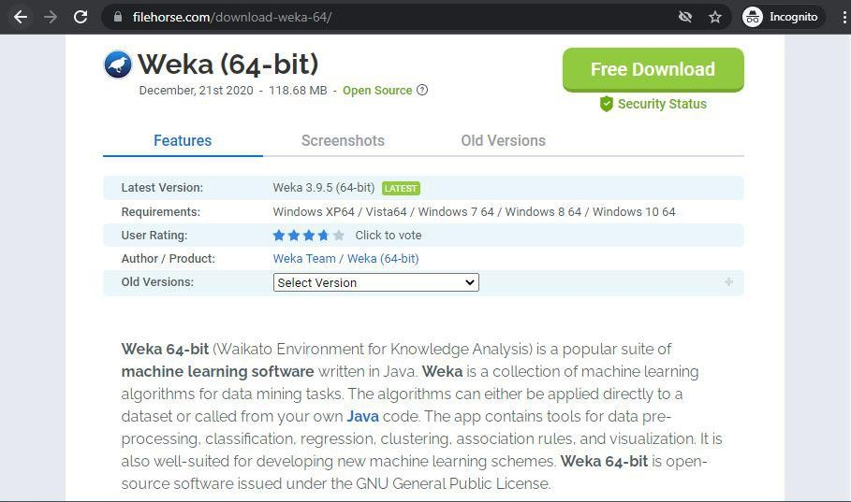

**Step 2**: It will redirect to a new webpage, click on Start Download. Downloading of the executable file will start shortly. It is a big 118 MB file that will take some minutes.

**Step 3**: Now check for the executable file in downloads in your system and run it.

**Step 4:** It will prompt confirmation to make changes to your system. Click on Yes.

**Step 5**: Setup screen will appear, click on Next.

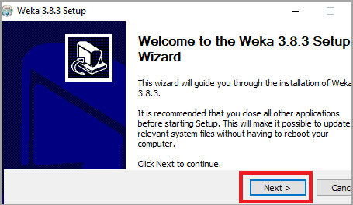

**Step 6:** The next screen will be of License Agreement, click on I Agree

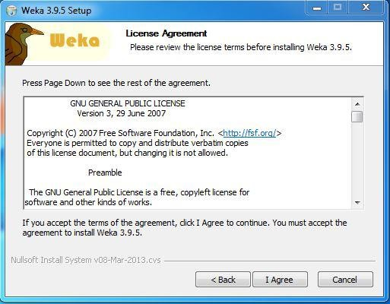

**Step 7:** Next screen is of choosing components, all components are already marked so don’t change anything just click on the Install button.

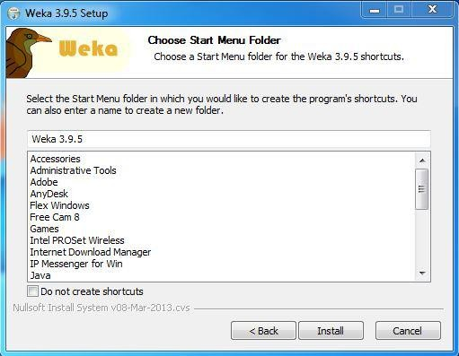

Step 8: The next screen will be of installing location so choose the drive which will have sufficient memory space for installation. It needed a memory space of 301 MB.

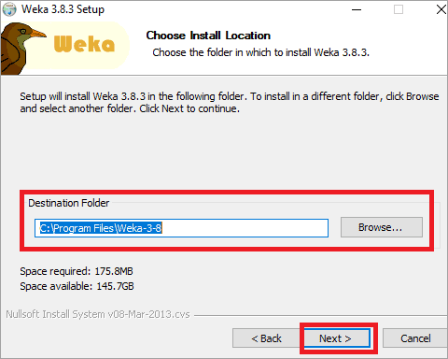

**Step 9**: Next screen will be of choosing the Start menu folder so don’t do anything just click on Install Button.

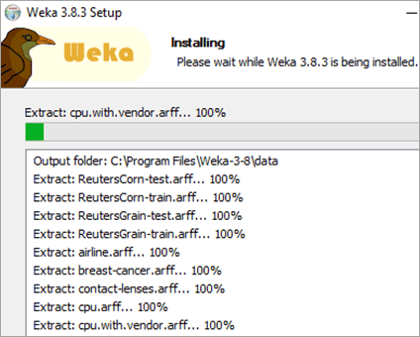

**Step 10:** After this installation process will start and will hardly take a minute to complete the installation.

**Step 11:** Click on the Next button after the installation process is complete.

**Step 12:** Click on Finish to finish the installation process.